M7.13 Interest Calculations- before/after 120 Days(Term. Ben. calc. Not Small Ben. Not Eligible-Vested)

**If calculated/paid before 120 Days there will interest added to the CV**

Member terminated October 31, 2022-Payment within 120 Days(December 12, 2022)

SID = 136395 Benefit Calculated

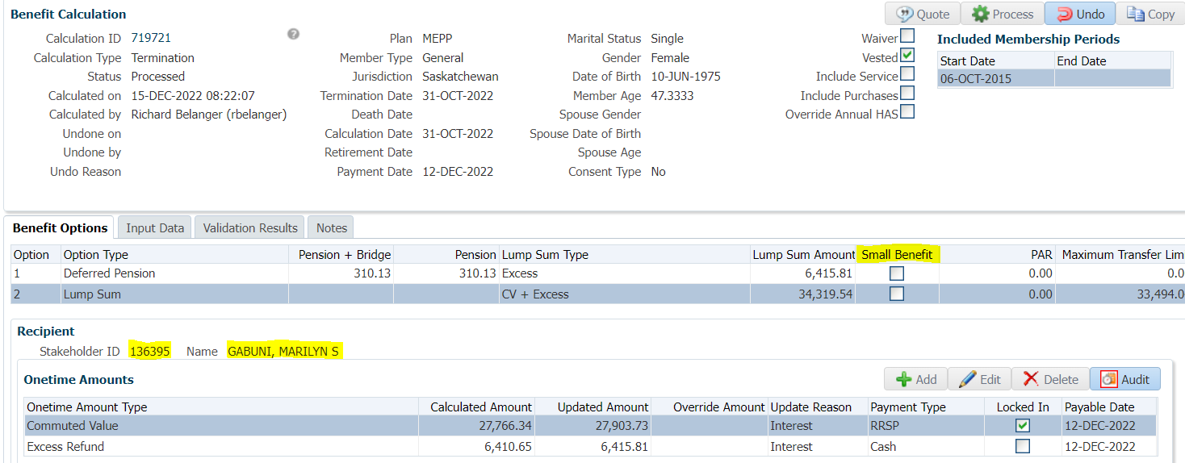

Interest added to CV (within 120 Days)

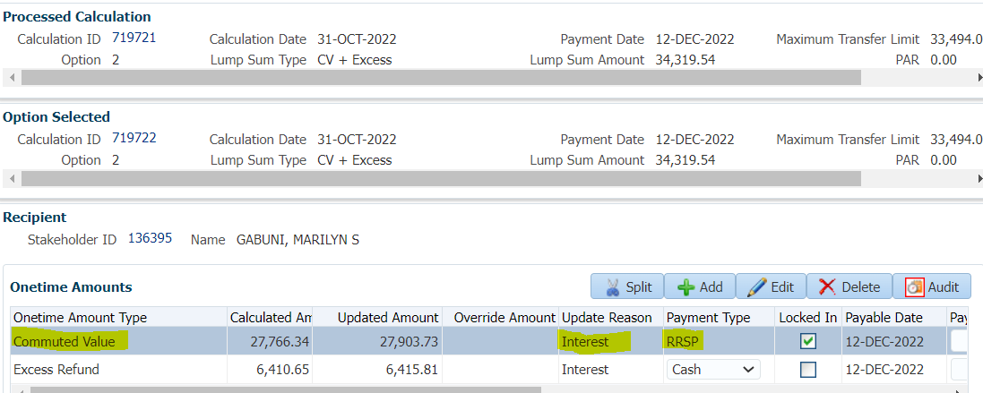

SID = 121966 Member terminated November 18, 2022-Payment within 120 Days(December 1, 2022)

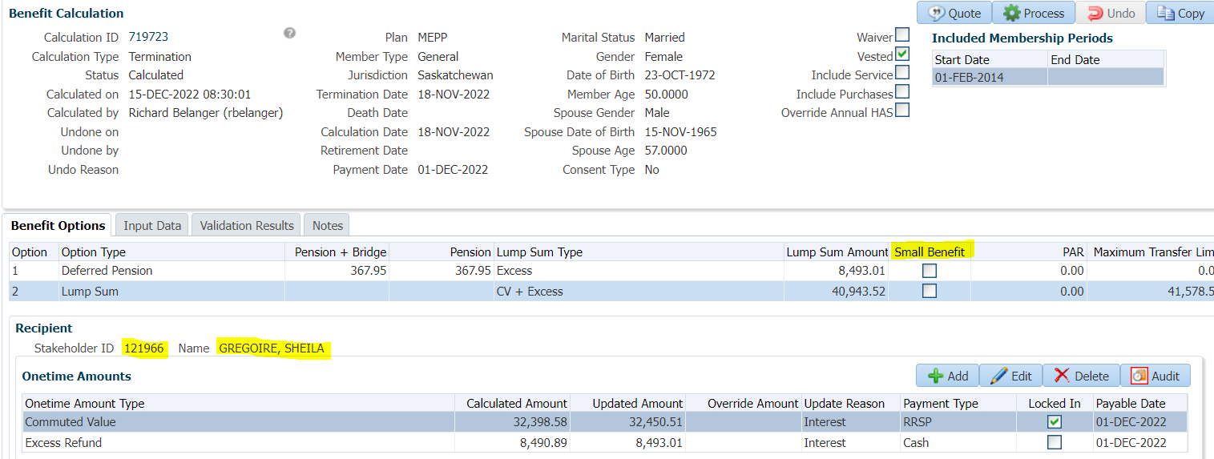

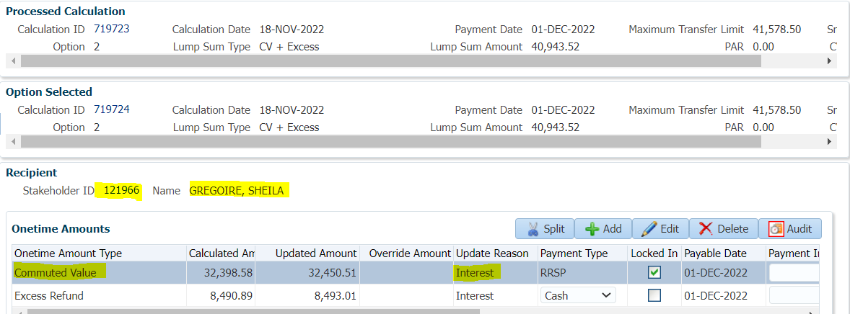

SID = 117379 Member terminated October 31, 2022-Payment within 120 Days(December 15, 2022)

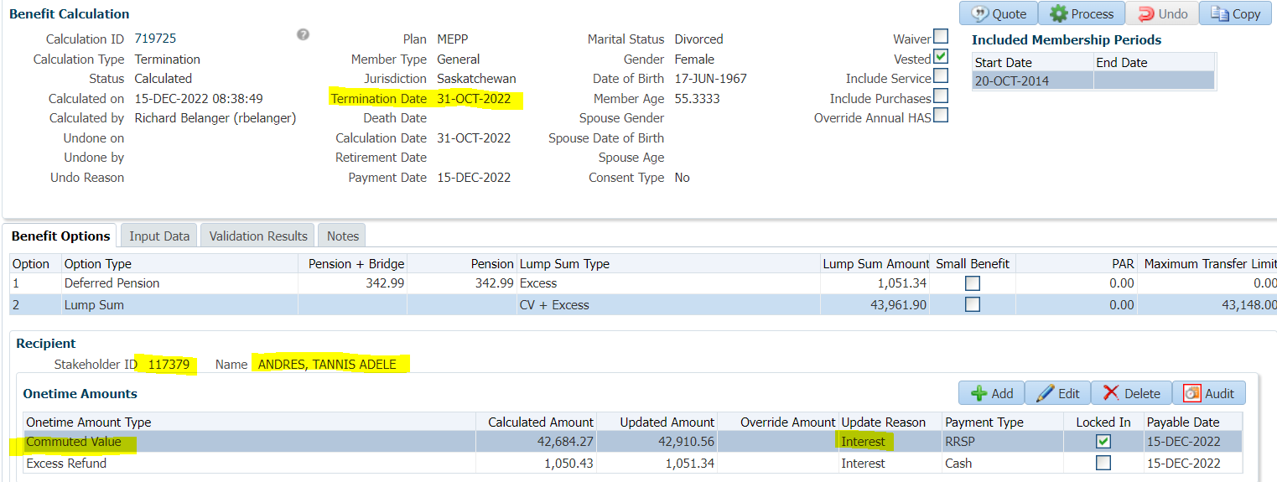

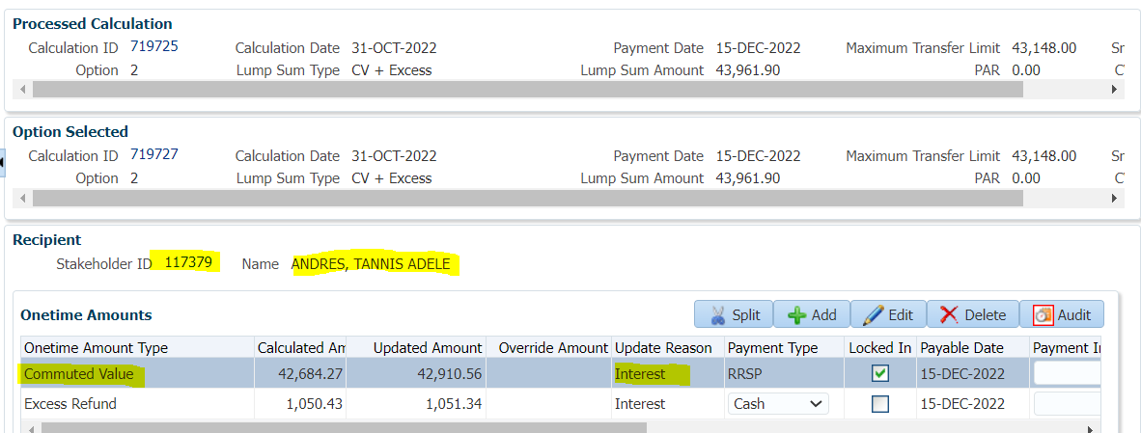

**If calculated/paid after 120 Days there will a re-calculation**

SID = 121634 Member terminated July 15, 2022-Payment after 120 Days(December 1, 2022)

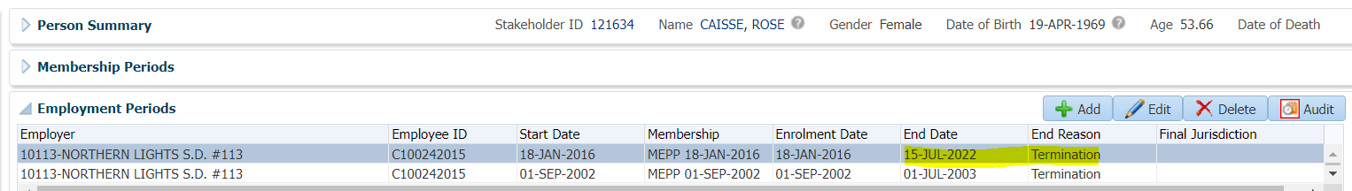

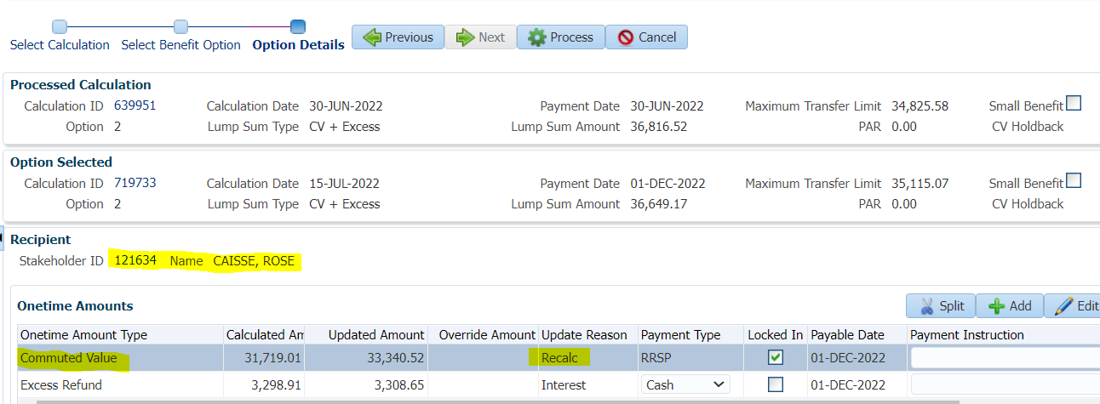

SID = 121634 Member terminated October 1, 2021-Payment after 120 Days(December 1, 2022)

